REPORT ON CNE-WORKSHOP ON WARD MANAGEMENT
(Funded by Ministry of Health and Family Welfare, GOI)
The first of its kind CNE – workshop on ward management funded by Ministry of Health and Family welfare was organized by Department of Nursing in AIIMS Mangalagiri. The workshop is based on the theme of ward management for 7 days from 05.02. 2024 to 11. 02. 2024 and each day one aspect of ward management is discussed in detail. The aim of the workshop is to sensitize the nursing personnel involved in ward management and administration on basics and latest trends in nursing services and administration in respect to ward management and also enable them to take up higher responsibilities in ward management for quality nursing services.
Registration held for the workshop is well organized and efficient. Participants easily completed the registration process started at 8.30am on 5th February 2024. Workshop welcome kits were distributed. The registration process contributed positively to the overall event management. The workshop commenced by pretest, allowing participants to gauge their baseline knowledge.
Inauguration
The workshop was inaugurated by galaxy of intellectuals -
- Prof. Dr. Desu Rama Mohan, Dean Examinations and HOD of Hospital Administration Dept
- Prof. Dr. Deepti Vepakooma, Dean Research and HOD of Pediatric Surgery dept
- Dr. Vineet Thomas Abraham, Medical Superintendent
- Colonel Shashikanth Thumma, DDA
- Prof. Dr. Danasu R, Principal cum CNO and Course Co-ordinator
All Deputy Medical Superintendents and faculties of various disciplines also attended inauguration ceremony of the workshop. The workshop was begun by lamp lighting by honourable dignitaries. Welcome address was given by Mr. Sharun N V, Associate Professor & DNS and briefing the event was given by Prof. Dr. Danasu R, Principal cum CNO and Course Co-ordinator. Opening remarks by Prof. Dr. Desu Rama Mohan, Dean Examinations and chief guest address was given by Prof. Dr. Deepti Vepakooma, Dean Research and Colonel Shashikanth Thumma, DDA. Followed by speeches, dignitaries were felicitated by saplings. Vote of Thanks was given by Mr. Dhanasekar V M. Nursing Tutor and IPD Nursing Incharge.
Day 01 – Introduction to Nursing Administration and management (05.02.2024)
Session 01: The main session started with an insightful introduction to administration, led by Dr. Vineet Thomas Abraham, Medical Superintendent, AIIMS Mangalagiri, guest speaker with an overview of nursing administration. Nursing administration involves managing healthcare services, overseeing nursing staff, and ensuring efficient delivery of patient care. Administrators in this field coordinate resources, develop policies, and focus on quality improvement within healthcare settings. Their responsibilities include staff supervision, budgeting, and collaboration with other healthcare professionals to enhance patient outcomes
Key points discussed:
- Nature and scope of administration
- Management process and levels of management
- Nursing Hierarchy

Session 02: The second session delved into the Importance of administration in nursing service by Prof. Dr. Danasu R, Principal and CNO, AIIMS Mangalagiri. In nursing, administration plays a crucial role in ensuring efficient and effective healthcare delivery. It improves the patient care, increases the efficient allocation of resources for optimal results, enhances the successful collaboration in nursing services
Key points discussed:
- Basic duties as a part of nurse administration
- Essentials of administration in nursing
- Patient advocacy
- Clinical leadership
- Staff management
- Quality improvement
- 10 scenario based work activity focusing on clinical expertise in policy implementation, quality improvement initiatives, and managing staff challenges.

Session 03: The third session was about differences between administration and management, led by Mr. Dhanasekar V M, Nursing Tutor, College of Nursing, AIIMS Mangalagiri. Administration involves planning, organizing, and coordinating resources to achieve organizational goals, focusing on broader policies and decision-making.
Management, on the other hand, deals with executing these plans, overseeing day-to-day operations, and ensuring tasks are carried out efficiently. While administration sets the direction, management implements and supervises to achieve the established objectives.
Key points discussed:
- Basic comparison focusing on meaning, authority, role, work function and applicability
- Management skills, technical skills, conceptual skills, people management skills, leadership skills, problem solving skills and time management skills.

Session 04: Management process by Mrs. Santhoshi, Nursing Tutor, College of Nursing, AIIMS Mangalagiri. A management process is a well-defined system of setting goals, planning and controlling any action’s execution. It constitutes a set of interrelated operations or functions necessary to accomplish desired organisational objectives.
Key points discussed:
- Concept of management
- Nursing process vs nursing management
- Role and functions of management
- The management process typically involves four main functions.
- Planning is the initial phase where goals and objectives are established, and the best course of action to achieve them is determined.
- In Organizing phase, resources are arranged and tasks are assigned to implement the plan.
- In directing, function involves motivating and guiding individuals or teams to work towards the organization's goals.
- Controlling is the final step, which involves monitoring performance against the plan, identifying any deviations, and taking corrective actions as needed.

Session 05: Principles, Levels and Functions of management by Mr. Sharun N, Associate Professor & DNS, College of Nursing, AIIMS Mangalagiri. Management involves several key principles, levels, and functions to effectively organize and achieve goals.
Key points discussed:
- Theories of management
- Henri Fayol’s 14 principles of management
- Challenges faced by management
- Future of management
- Levels and functions of management
- Four scenario based work activities focusing on strategical decision making skills
Session 06: Trends and issues in nursing services by Mrs. Avanthi Devi, Nursing tutor, College of Nursing, AIIMS Mangalagiri. Some current trends and issues in nursing services include the increasing use of technology for patient care, the growing emphasis on mental health support, the ongoing need for workforce development and training, and the importance of addressing healthcare disparities. Additionally, the COVID-19 pandemic has highlighted challenges such as staffing shortages and the need for resilience in the nursing profession.
Key points discussed:
- Perspectives of nursing before and after independence
- Factors affecting trends in Nursing
- Issues in Nursing and administration
- Effective strategies for improving issues Nursing administration

Day 02: Planning in Nursing Services (06.02.2024)
Second day started by review of previous day activity by delegates, facilitated by Prof. Dr. Danasu R, Principal and CNO and Course Coordinator of Workshop.
Session 01: Types of planning and Planning process in nursing services by Mrs. Ambili, Nursing tutor, College of Nursing, AIIMS Mangalagiri thus provide a rational approach to achieving pre-selected objectives. Planning involves selecting missions and objectives and deciding on the actions to achieve them; it requires decision-making, i.e., choosing a course of action from among alternatives.
Key points discussed:
- Planning - Characteristics, Importance and hierarchical models
- Strategic planning
- Intermediate/ functional planning
- Operational planning
- Planning process in Nursing services
- Steps of problem solving
- 4 scenario based activity focusing on ward issues and keys for strategic planning.
Session 02: Broad areas of nursing services by Mrs. Vetrichelvi S B, Nursing Officer, NIE, AIIMS Mangalagiri. Nursing service is the part of the total health organization which aims at satisfying the nursing needs of the patients/community.
Key points discussed:
- Management of Nursing care and services
- Research
- Education, training and staff development
- Community based health programs
- 3 scenario based work activity based on risk assessment, managing challenging situation and shift.
Session 03: Factors influencing ward management by Mr. Shinoj T, Senior Nursing Officer, AIIMS Mangalagiri. Effective ward management is crucial for providing quality healthcare services and ensuring patient safety.
Key points discussed:
- Characteristics of management
- Knowledge of the ward
- Establishment of ward routines
- Time management
- Preventing interruptions
- Democratic methods
- Delegation of responsibilities
- Records and reports maintenance
Session 04: SWOT Analysis by Dr. Vamsi Krishna Reddy, guest speaker, Associate Professor & DNS, Department of Hospital Administration, AIIMS Mangalagiri.
Key points discussed:
- Definition of SWOT
- Aim and need of SWOT
- Guidelines to conduct SWOT analysis
- Pitfalls of SWOT analysis
Session 05: Methods of patient assignment/ Nursing care delivery system by Mr. Sharun N V. There are many different types of nursing care delivery models used to organize and provide care in hospitals.
Key points discussed:
- Functional nursing
- Team nursing
- Primary nursing
- Total patient care
- Case management
- Patient centred care
- Hybrid models
- Scenario based work activity
Session 06: Management of Nursing Personnel- Planning and calculation of staffing requirement for a nursing unit/ ward by Mr. Dhanasekar V M, Nursing Tutor and IPD Nursing Incharge.
Key points discussed:
- Meaning of Staffing
- Criteria for effective staffing procedure
- Allocation of staffing procedure
- Assessment of patient needs
- Nurse to patient ratio
- Staff input
- Work activity given on calculation of staff for various categories of patients.
Day 03: Organization of Nursing Services (07.02.2024)
Third day started by the review of previous day's activity
Session 01: Organization of ward and preparation of organogram by Mr. Sudheendra M, Assistant Professor, College of Nursing, AIIMS Mangalagiri. Organizing a ward and preparing an organogram involves creating visual representation of the staff hierarchy and their roles.
Key points discussed:
- Staff hierarchy
- Organogram
Session 02: Nursing rounds by Mrs. Y V M Nakshatram, Nursing tutor, College of Nursing, AIIMS Mangalagiri. Nursing rounds are a crucial aspect of healthcare that involves regular visits by nursing staff to patients. These rounds aim to assess patients’ conditions, provide necessary care, and promote effective communication between healthcare professionals.
Key points discussed:
- Importance of nurse in rounds
- Purpose of nursing rounds
- Types of conducting nursing rounds
- Scope of nurse led ward rounds
- Nurses role in rounds
Session 03: Indenting protocol by Dr. Purushotham Lingaiah, guest speaker, Associate Professor & DMS, Department of Orthopedics, AIIMS Mangalagiri.
Key points discussed:
- Pop-up sign for Expiry drugs and Low Stock.
- Offline Indent writing.
- Indenting protocol followed in AIIMS Mangalagiri
Session 04: Record Maintenance in ward by Mrs. Priya M, Nursing tutor, College of Nursing, AIIMS Mangalagiri. Record is a written report of any facts. Nursing records are important for the stand point of patients, nurses, and the hospital, for nursing education and research.
Key points discussed:
- Purposes and importance of records
- Principles of recording
- Essentials of good document
- Nursing administrative

Session 05: Nursing services meetings by Mr. Saravanan M R, Nursing Officer, NIE, AIIMS Mangalagiri.
Key points discussed:
- Importance of nursing services meeting ,its types and process of meeting .
- Key players in any nursing services related meeting .
- Preparation of agenda and minutes of meeting .
Session 06: Staff development programme by Prof. Dr. Danasu, Principal& CNO, AIIMS Mangalagiri
Key points discussed:
- Concept, Principles, needs, models, methods and types of SDP
- In service education, orientation, induction and CNE
- Organization of CNE
- Preparation of Budget for CNE
Day 04: Staffing in nursing (08.02.2024)
4th day also started by the review of previous days’s activity
Session 01: Staffing: Importance & purposes by Prof. Radha Ramana Sri, Guest speaker, Principal, College of Nursing GGH, Guntur.
Key points discussed:
- Staffing norms
- Importance of staffing
- Principles of staffing
- Patient classification system
- Recommendation by committees
Session 02: Calculation of staffing requirements for a nursing unit / ward as per norms and factors affecting staffing pattern by Mrs. Priya M, Nursing Tutor, College of Nursing, AIIMS Mangalagiri.
Key points discussed:
- Patient factors, staff factors, hospital organization factors, nursing service related factors.
- Legislative and regulatory factors
- Suggestions for issues in staffing
- Staffing norms
- Recommendations by various committees
- Calculation of nursing personnel for each units
- 3 scenarios based group activities on staffing
Session 04: Formulation of job description for Nursing Personnel by Mrs. Kaleeshwari G, Nursing Tutor, College of Nursing, AIIMS Mangalagiri
- Key points discussed:
- Concept and meaning
- Purpose, components
- Criteria and guidelines for development of job description
- Advantages and limitations
Session 05: Patient classification system by Mr. Arvind Joshi, Nursing Tutor, College of Nursing, AIIMS Mangalagiri.
Key points discussed:
- Importance, components, theoretical application
- Workload measurement tools
- Modified approach to nursing, staffing, and scheduling
Session 06: Preparation of Duty Roster for staff at different levels by Mrs. Santhoshi, Nursing Tutor, College of Nursing, AIIMS Mangalagiri.
Key points discussed:
- Steps in planning the duty roster
- Benefits
- Points to remember during staff formulation
Session 07: Performance appraisal / Evaluation of nursing staff by Mrs. Ambili, Nursing Tutor, College of Nursing, AIIMS Mangalagiri
Key points discussed:
- Characteristics, purposes, criteria
- Performance appraisal process
- Limitations

DAY 05: CO-ORDINATION & CONTROL IN NURSING SERVICES (09.02.2024)
Session started by review of the previous day's session
Session 01: Co-ordination of Nursing services by Mr. Sudheendra M, Assistant Professor, College of Nursing, AIIMS Mangalagiri
Key points discussed:
- Planning and organizing
- Communication
- Leadership
- Scenarios based on co-ordination concepts
Session 02: Principles of co-ordination by Dr. Ramya Jothi, Guest speaker, Assistant Professor & DMS, Department of Hospital Administration, AIIMS Mangalagiri.
Key points discussed:
- Elements, types, principles of coordination
- Advantages , additional principles of coordination
- Systems approach of management
- Functions of co-ordination
Session 03: Control process and delegation of responsibities by Mrs. Sandhya, Nursing Tutor, College of Nursing, AIIMS Mangalagiri.
Key points discussed:
- Controls as management tool
- Quality control steps
- Control process in nursing
- Establishment of standards
- Measurement of performance
- Methods of nursing control
- Case scenarios
Session 04: Communication in Nursing by Mr. Balarama, Nursing Tutor, College of Nursing, AIIMS Mangalagiri
Key points discussed:
- Communication process
- Major dimensions, types, theories and principles of communication
- Factors influencing communication
Session 05: Disciplinary proceedings & Conflict management by Mr. Sharun N V, Associate Professor, College of Nursing, AIIMS Mangalagiri
Key points discussed:
- DoPT
- CCS CCA Rules- Leave rules
- Types of leaves
- Overview of disciplinary proceedings
- Censure Vs Memo
- Major penalties
- Conflict management- workload and staffing issues, inter professional disputes, personality clashes
Session 06: Multidisciplinary approaches by Mrs. Y V M Nakshatram, Nursing Tutor, College of Nursing, AIIMS Mangalagiri
Key points discussed:
- Concept
- Multi disciplinary team
- Patient pathway
- Roles and responsibilities of multi-disciplinary team members

DAY 06: RECORDING AND REPORTING IN NURSING (10.02.2024)
Started by review of the previous day's session
Session 01: Importance and purpose of Records and Reports by Mr. Balarama, Nursing Tutor, College of Nursing, AIIMS Mangalagiri.
Key points discussed:
- Concept of records and reports
- Purposes of records and reports
- Importance of records and reports
Session 02: Principles of Recording and Reporting by Mr. Sudheendra M, Assistant Professor,College of Nursing, AIIMS Mangalagiri.
Key points discussed:
- Principles of recording and reporting
- Filling and arranging of records
- Record keeping system
- Guidelines for documentation and record keeping
Session 03: Types of Records & Reports by Mrs. Padma, Nursing Tutor, College of Nursing, AIIMS Mangalagiri.
Key points discussed:
- Types of records
- List of nursing records
- Types of change of shift record
- Computerized records
Session 04: Preparation and presentation of handing over and taking over report - ISBAR Technique by Mr. Dhanasekar V M, Nursing Tutor, College of Nursing, AIIMS Mangalagiri.
Key points discussed:
- Types of handover
- Scenario
- ISBAR- Introduction, Situation, Background, Assessment, Recommendation
Session 05: MRD (Medical Record Department) and its Functions by Mr. Arvind Joshi, Nursing Tutor, College of Nursing, AIIMS Mangalagiri.
Key points discussed:
- Definition, purposes of MRD
- Physical facilities
- Process of records and retrieval
- Coding and indexing
- Storage and retrieval
- Medico legal aspects of medical records
Session 06: Records and registers maintained in wards and role of nurse in maintaining records and reports by Mrs. Anu C Vijay, Nursing Tutor, College of Nursing AIIMS Mangalagiri.
Key points discussed:
- Registers used in direct patient management
- Registers used for management
- Registers used for managing Nursing Officers
- Role of Nurse in maintaining records and reports
- Case scenarios based on records and reports
Session 07: Medico Legal Case related records by Dr. Harideep Yellamilli, Guest Speaker, Assistant Professor,Dept of Trauma and Emergency Medicine,AIIMS Mangalagiri.
Key points discussed:
- Documentation, Case sheets
- Types of Case Sheets
- Police intimation
- Reports- Details to be mentioned in nursing notes

DAY 07: MATERIAL MANAGEMENT (11.02.2024)
Session started by review of previous day session
Session 01: Material management – concepts, purposes & principles by Mr. Harsha G, Nursing Tutor College of Nursing, AIIMS Mangalagiri
Key points discussed:
- Concept, purpose, goals, need, aim
- Functional areas of material management
- Subsystems of material management
Session 02: Principles of material management by Mr. Vikas Miskin, Nursing Tutor College of Nursing, AIIMS Mangalagiri
Key points discussed:
- Basic principles, elements
- Sound purchasing methods, negotiations
- Simple inventory control programme

Session 03: Demand forecast & Procurement by Dr. Prudhvinath Reddy, Guest speaker, Associate Professor & DMS, Department of Hospital Administration, AIIMS Mangalagiri
Key points discussed:
Process and methods of procurement in INI’s and prediction of demand through utilization and consumption of items based on duration,period and types of items consumed.
Session 04: Inventory control by Mr. Sujeeth Mathew, Nursing Officer, NIE, AIIMS Mangalagiri.
Key points discussed:
- Importance of ABC’s in inventory control and maintenance.
- Segregation and accounting of fast moving and slow moving items .
Session 05: Disposal & condemnation, Role of Nurse in Material management by Mr. Bibinlal, Nursing Tutor, College of Nursing, AIIMS Mangalagiri
Key points discussed:
Proper channel for disposal and condemnation of various items used in healthcare setting.
CONCLUSION
Session came to an end by a post test by NIE followed by course feedback from the delegates, glimpse and overview of the 7 days workshop, Pre and post test scores evaluation and valediction by dignitaries DDA, Dean examination, Principal & CNO and faculties of department of Nursing attended.

GLIMPSE OF WORKSHOP
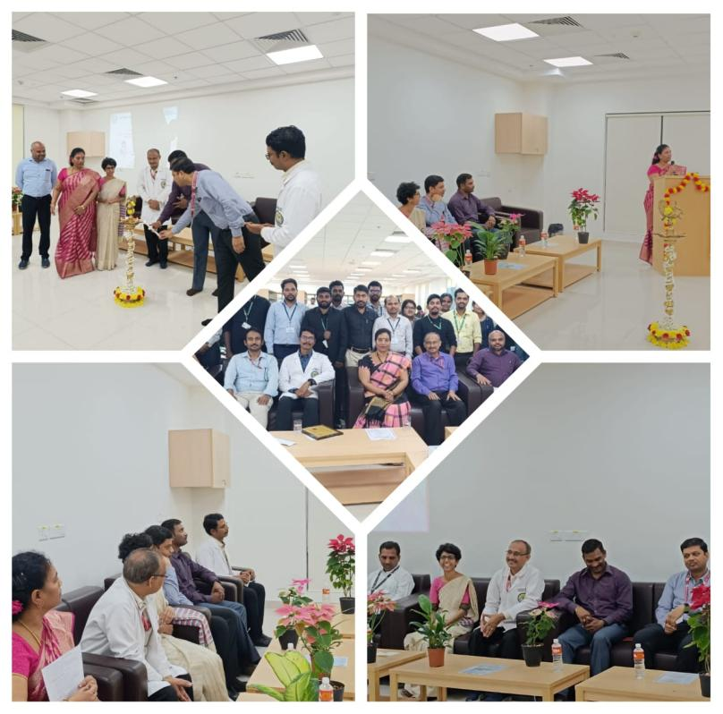 | 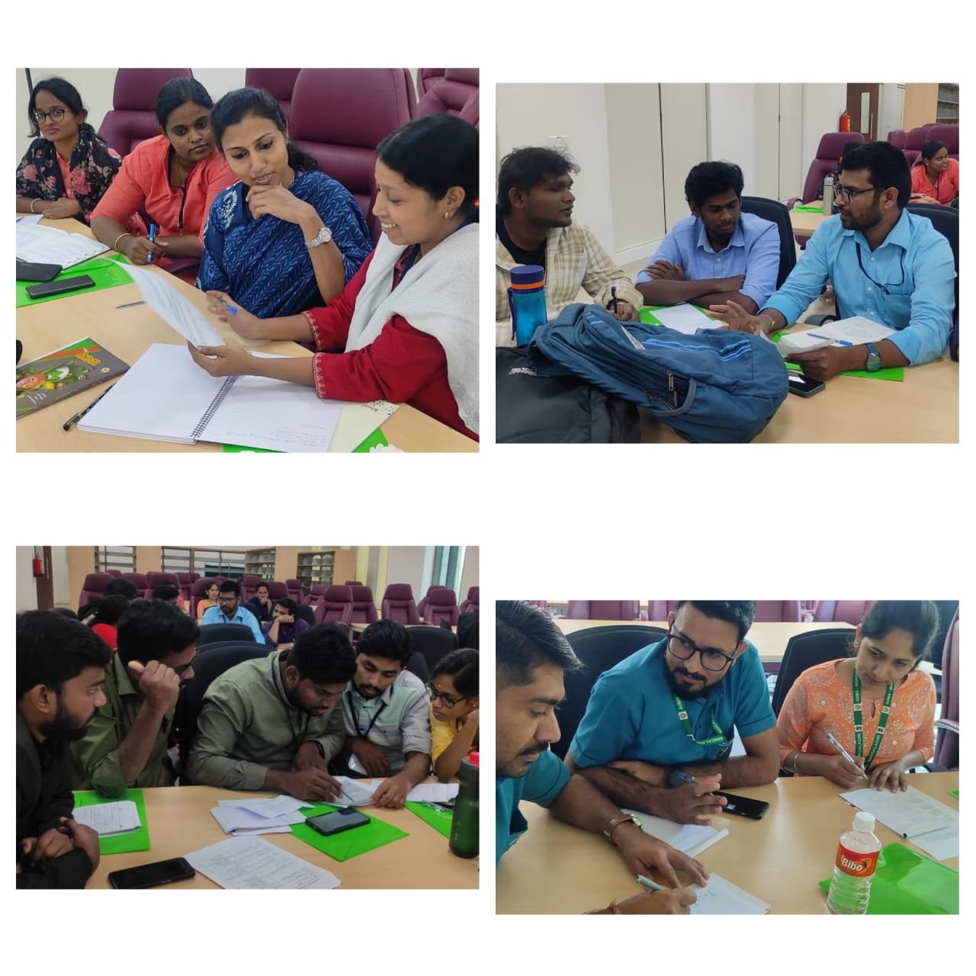
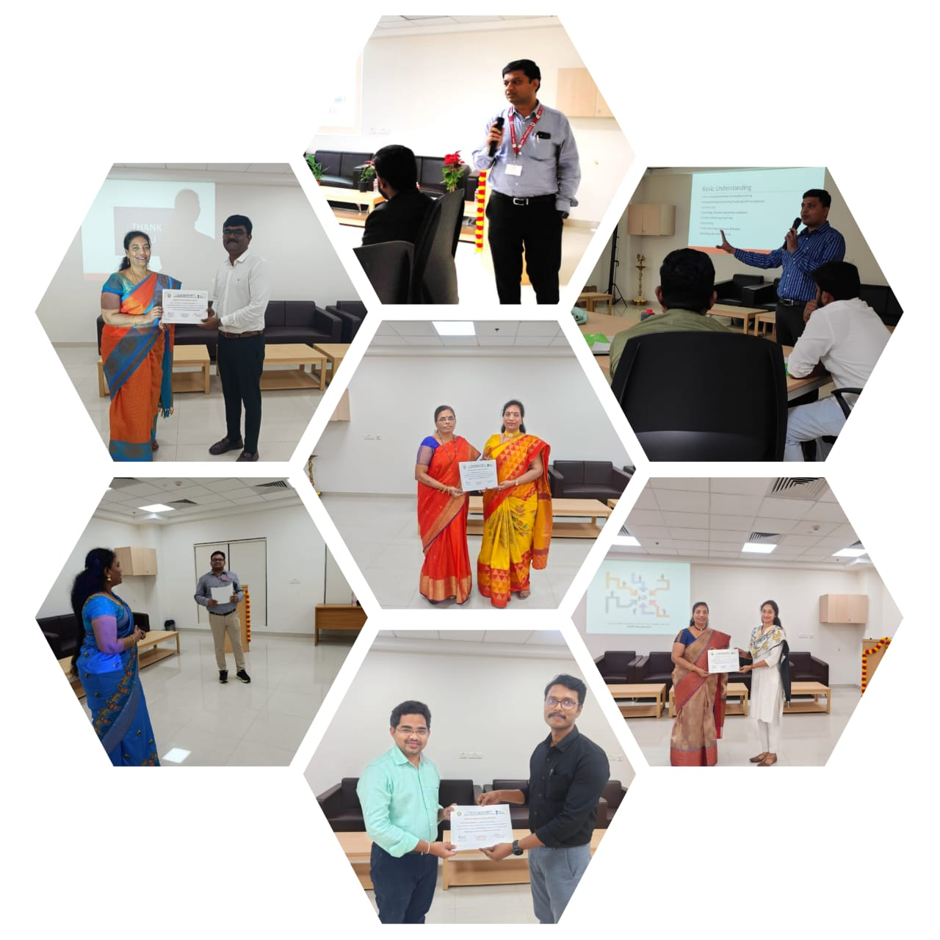 | 