**Curriculum Vitae**

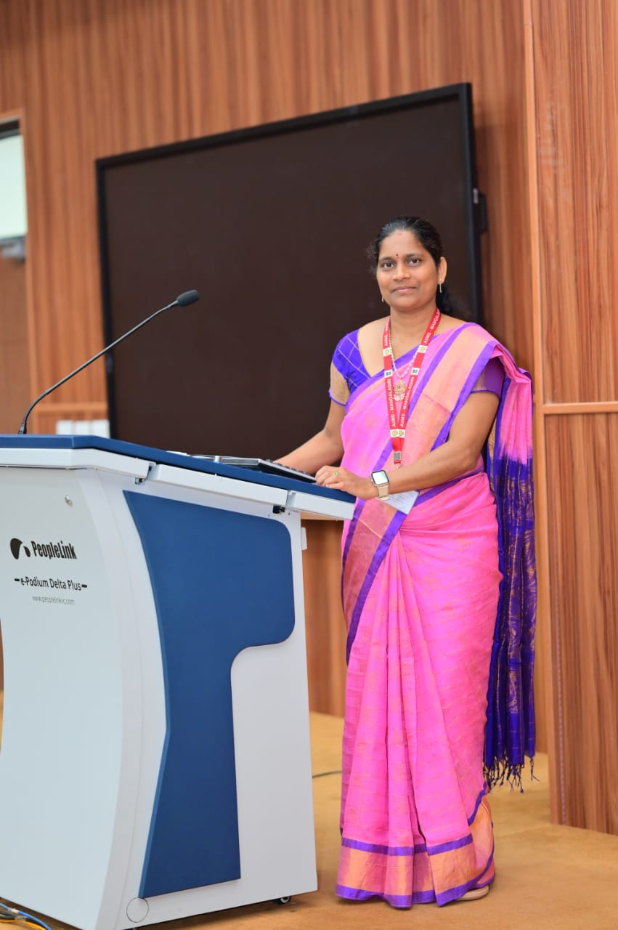

**Name:** Mrs Vallepu Padma

**Designation:** Nursing Tutor

**Department:** Mental health (Psychiatric)Nursing

**Email id:** padma.vallepu123@aiimsmangalagiri.edu.in

**Educational qualification**

|  |  |  |  |  |
| --- | --- | --- | --- | --- |
| Sl. No. | Degree | Year of passing | Subject | College/University |
| 1 | Bsc | 2010 | Nursing | DR NTRUHS |
| 2 | MSc nursing | 2014 | Mental health (Psychiatric)Nursing | SVIMS TIRUPATI |

**Area of interest:**

* Adolescent counseling
* Child Psychology
* Therapeutic modalities and therapies

**Publications (Chronologically, Recent First ):**

1.(A Study to Assess the Parental attachment and Self-esteem among adolecents of selected colleges at Tirupati). (International journal of pharmaceutical research and bio-science)