**Curriculum Vitae**

**Name:** Mrs G. Kaleeswari

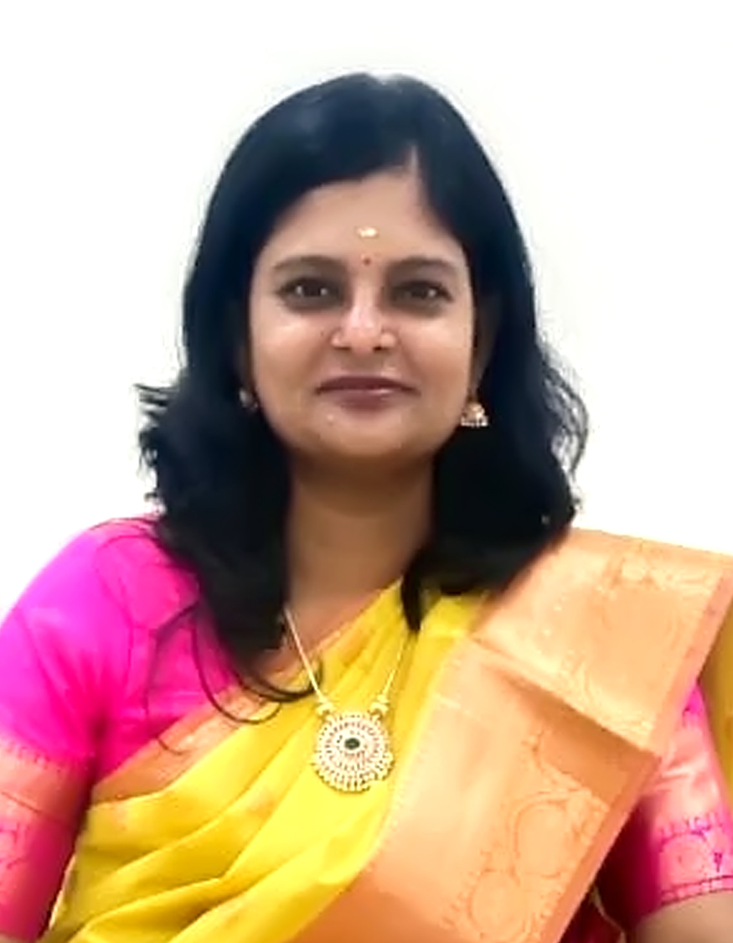****

**Designation:** Nursing Tutor/Clinical Instructor

**Department:** Community Health Nursing

**Email id:** kalisaiims@aiimsmangalagiri.edu.in

**Educational qualification**

|  |  |  |  |  |
| --- | --- | --- | --- | --- |
| **Sl. No.** | **Degree** | **Year of passing** | **Subject** | **College/University** |
| 1 | B.Sc Nursing | 2006 | Nursing | Dhanvantri college of Nursing  The TamilNadu Dr.MGR Medical University, Chennai |
| 2 | MSc Nursing | 2012 | Community Health Nursing | Sri Ramachandra University, Chennai |
| 3 | PhD | Scholar | Community Health Nursing | BIHER, Chennai |
| 4 | Any Other | PGD YOGA | Yoga | TamilNadu Physical Education and Sports University, Chennai |

**Certificate of completion:**

1. Foundational course on social and behavioural change communication by UNICEF
2. Advanced diet and Nutrition therapy
3. Research methods in Health Promotion
4. Level I Simulation educator (Pedi Stars)
5. Master diploma in counselling psychology

**Research Profile:**

**Research gate:** <https://www.researchgate.net/profile/Kaleeswari-Gunasekaran>

**Any Other:** https://orcid.org/0000-0001-7736-2403

**Area of interest:**

1. Prevention of Adolescent anemia.
2. Community –based antenatal care.
3. Nurse led Community-Immunization clinics,campaigns,outreach activities against Childhood Vaccine preventable diseases.
4. National Digital Health Mission
5. Community -based Palliative care (Prevention, Early identification, Relieving spiritualdistress).
6. Complementary Therapy : Yoga
7. Community emerging diseases

**Membership of professional bodies:**

1. Nutritional Society of India
2. SOCHINI: Vellore, Tamilnadu
3. Trained Nurses Association of India
4. Indian Red Cross society

**Honors and awards:**

1. Best Yoga Teacher Award from TamilNadu Sports Yogasana Association
2. Best Faculty Award

**Publications (Chronologically, Recent First ):**

1.G.Kaleeswari, Dr. S. Rajalakshmi,2024.Prevalence, Awareness and Predisposing factors for Polycystic Ovarian Syndrome (PCOS) among young women in selected PHC. Available from <https://kuey.net/index.php/kuey/article/view/4117>

2. Conference proceedings: Effectiveness of planned teaching programme on awareness and attitude regarding early identification and management of polycystic ovarian syndrome among adolescent girls in selected hospital, 2023, ICAESM’2023 Conference ISBN No.978-93-5981-580

3. Neetu kataria, vasantha c kalyani, Sonia Gulia,Kaleeswari Gunasekaran, 2023. Knowledge Regarding Hypertension and Amount of Diet Consumption Among Adults FromUttarakhand: A Comparative Survey. Available from: <https://www.researchgate.net/publication/370828251_Knowledg>e_Regarding_Hypertension_and_Amount_of_Diet_Consumption_Among_Adults_From_Uttarakhand_A_Comparative_Survey#fullTextFileContent

4 .G. Kaleeswari, C. Vasantha Kalyani, J.S. Jarani, Kusum K.Rohilla, 2021.Effect of yoga on pulse rate and blood pressure among women https://www.researchgate.net/publication/353681979_Effect_of_yoga_on_pulse_rate_and_blood_pressure_among_women/stats

5..Kaleeswari G. Effect of Ajwain oil inunction on joint for pain among elderly, 2019, 6(6) :49-60. Availablefrom:https://www.researchgate.net/publication/348870352_AJANR_-_Ajwain_oil_inunction_on_joint_for_pain_among_elderly

6.Conference proceedings: Assessment of nutritional status in a pregnant women cohort examining health effects of air pollution: Preliminary results from the SICAPHE study.September 2013. ISEE Conference Abstracts 2013(1):5200.DOI: 10.1289/isee.2013.P-3-15-04