**Curriculum Vitae**

**Name: Mr Bibinlal O**

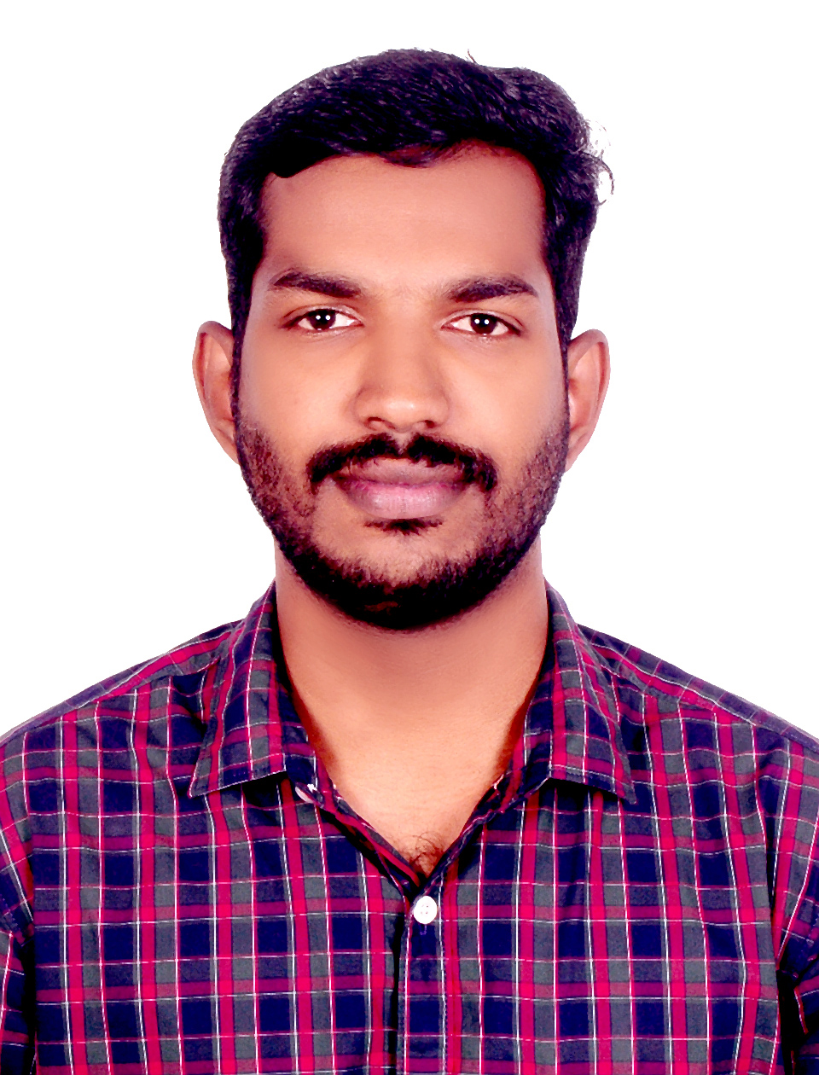

**Designation: Nursing Tutor / Clinical Instructor**

**Department: Medical Surgical Nursing**

**Email id: bibinlal4777@aiimsmangalagiri.edu.in**

**Educational qualification**

|  |  |  |  |  |
| --- | --- | --- | --- | --- |
| Sl. No. | Degree | Year of passing | Subject | College/University |
| 1 | Diploma in GNM | 2011 |  | Govt. School of Nursing, Kozhikode, Kerala. |
| 2 | B. Sc. Nursing Post Basic | 2014 |  | PGIMER, Chandigarh. |
| 3 | MSc | 2022 | Neuro science Nursing | AIIMS New Delhi |

**Research Profile:**

**Any Other:** 0009-0004-0056-2764 ORCID ID

**Area of interest:**

* Clinical research in Stroke and post operative neurosurgical and cardiology patients

**Membership of professional bodies:**

* 1. Executive member of Society of Cardiac Nurses (SOCN) India. No.2020/12/0018/LTM
  2. Life time member of TNAI. No: 387824/LMT/KL
  3. Life time member of Society of Indian Neuroscience Nurses (SINN) No: 684
  4. Lifetime member of Society of Neurocritical Care (SNCC) SNCC membership number is: SNCC/22/0265

**Honors and awards:**

1. **ACLS / BLS** trainer and provider
2. **3rd prize** winner in Scientific Paper Presentation (UGs), conducted during 36th Annual conference of the SINNCON- 2015 on 17th -20th December 2015, Hyderabad.
3. **1st prize** winner in the E poster Paper presentation at DNACON 2016 on 23rd & 24th January 2016 at Delhi.
4. Poster presentation in the 10th World Stroke Congress Hyderabad, India October 26-29, 2016.
5. **2nd Prize in Cardiology Quiz competition** by Department of CNE, Cardiothoracic Centre, AIIMS, New Delhi on 27/02/2018.
6. Organiser in the two-day Infection Control Workshop for Health Care Personnel under Swachhata Action Plan held 4th-5th April, 2018 at AIIMS New Delhi.
7. **Awarded Virtual Stroke Nurse Certification Course** by Society of Indian Neuroscience Nurses (SINN) and ECHO- India in February 2020
8. **2nd Prize in Quiz Competition** in Nursing CME 3rd Annual Conference of Neurocritical Care Society of India (NCSI 2022) held on 6th October, 2022 at AIIMS, New Delhi.
9. **1st Prize in Award Paper Presentation (PG Category)** 42nd Annual Conference of the Society of Indian Neuroscience Nurses SIINCON-2022 during 70th Annual Conference of Neurological Society of India (NSICON-2022) held on December 9th-10th, 2022 at Agra UP, India
10. **2nd Prize in Neuroscience Quiz Competition (PG Category)** 42nd Annual Conference of the Society of Indian Neuroscience Nurses SIINCON-2022 during 70th Annual Conference of Neurological Society of India (NSICON-2022) held on December 9th-10th, 2022 at Agra UP, India
11. **2nd Prize in Elocution Competition (PG Category)** 42nd Annual Conference of the Society of Indian Neuroscience Nurses SIINCON-2022 during 70th Annual Conference of Neurological Society of India (NSICON-2022) held on December 9th-10th, 2022 at Agra UP, India
12. **1st Prize in Scientific Paper Presentation** in the National Workshop organised by Rajkumari Amrit Kaur College of Nursing, Directorate General of Health Services University of Delhi.
13. **2nd Prize in Critics Research Awards Nursing Category** during 2nd Annual Research Day, AIIMS New Delhion 18th October, 2022.
14. **3rd Prize** in the **All-India Outstanding Nursing Research Award PG Thesis Category** by Clinical Nursing Research Society (CNRS) North Zone 5th May 2022.

**Publications (Chronologically, Recent First ):**

1. O Bibinlal, Dhandapani M, B Latika. Prevalent risk factors: Awareness and health practices among the post haemorrhagic stroke patients. Conference publication. International Journal of Stroke. 11(35); 142.