**Curriculum Vitae**

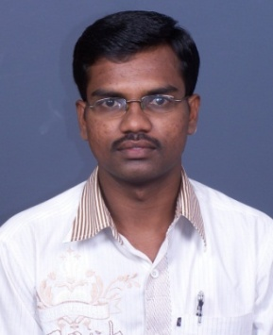

**Name:** Mr Balarama V R

**Designation:** Nursing Tutor / Clinical Instructor

**Department:** Community Health Nursing

**Email id:** balaramabv@aiimsmangalagiri.edu.in

**Educational qualification**

|  |  |  |  |  |
| --- | --- | --- | --- | --- |
| Sl. No. | Degree | Year of passing | Subject | College/University |
| 1 | B.Sc (N) | 2005 | **BSc Nursing** | Government College of Nursing. Bangalore/ RGUHS Karnataka |
| 2 | M.Sc (N) | 2010 | Community Health Nursing | Father Muller College of Nursing. Mangalore / RGUHS |
| 3 | M.Sc (Psychology) | 2013 | Psychology | Madras University – Institute of Distance Education |

**Research Profile:**

**Researchgate: https**: //www.researchgate.net/scientific-contributions/V-R-Balarama-2124886217

**Area of interest:**

Public Health, Public Health Insurance, Programme Evaluation and Epidemiology

**Publications (Chronologically, Recent First ):**

1. Balarama V R. Teaching and Learning Activities: Satisfaction of Nurse Educators and Student Nurses. International Journal of Nursing Education. 5(2); 24. doi: [10.5958/j.0974-9357.5.2.058](http://dx.doi.org/10.5958/j.0974-9357.5.2.058)